Record No: 0593
DANIEL O’CONNOR
of Shoreham, Sussex

Father of Cecilla Eliza O’Connor (0592).

Birth: about 1778
Marriage: 1 Ellen Walplate, mother of Isabella, who married Ewer Benn
- Elizabeth Ritchie, Daughter of John Ritchie of Brighton, mother of Erina, who married Hampton Leedom and Cecilia Eliza who married Tenison Alan Somerville. Elizabeth Ritchie died, aged 23, when Cecilia Eliza was about 18 months old.
- Elizabeth Naggs, Daughter of George Naggs of Co Tipperary, mother of George O’Connor.
Death:

.

Source: Somerville Index.

Notes: Daniel O’Connor seems to have been a colourful character, although he was said to have been a womanizer. More information is available, but, at present, is not to hand.
His daughter Isabella, always referred to in the Somervile family as ‘Aunt Benn’ brought up her two half sisters and remained close to them all her life. George O’Connor, the son of the third marriage, went to America in 1839 and prospected for silver. By the time of his death, he had an interest in several silver mines in the west and there is quite a volume of correspondence regarding the possibility of a claim, after his death, unmarried and childless, but the correspondence is inconclusive as to the result.

Source: WBRBS from notes left by Lily Somerville

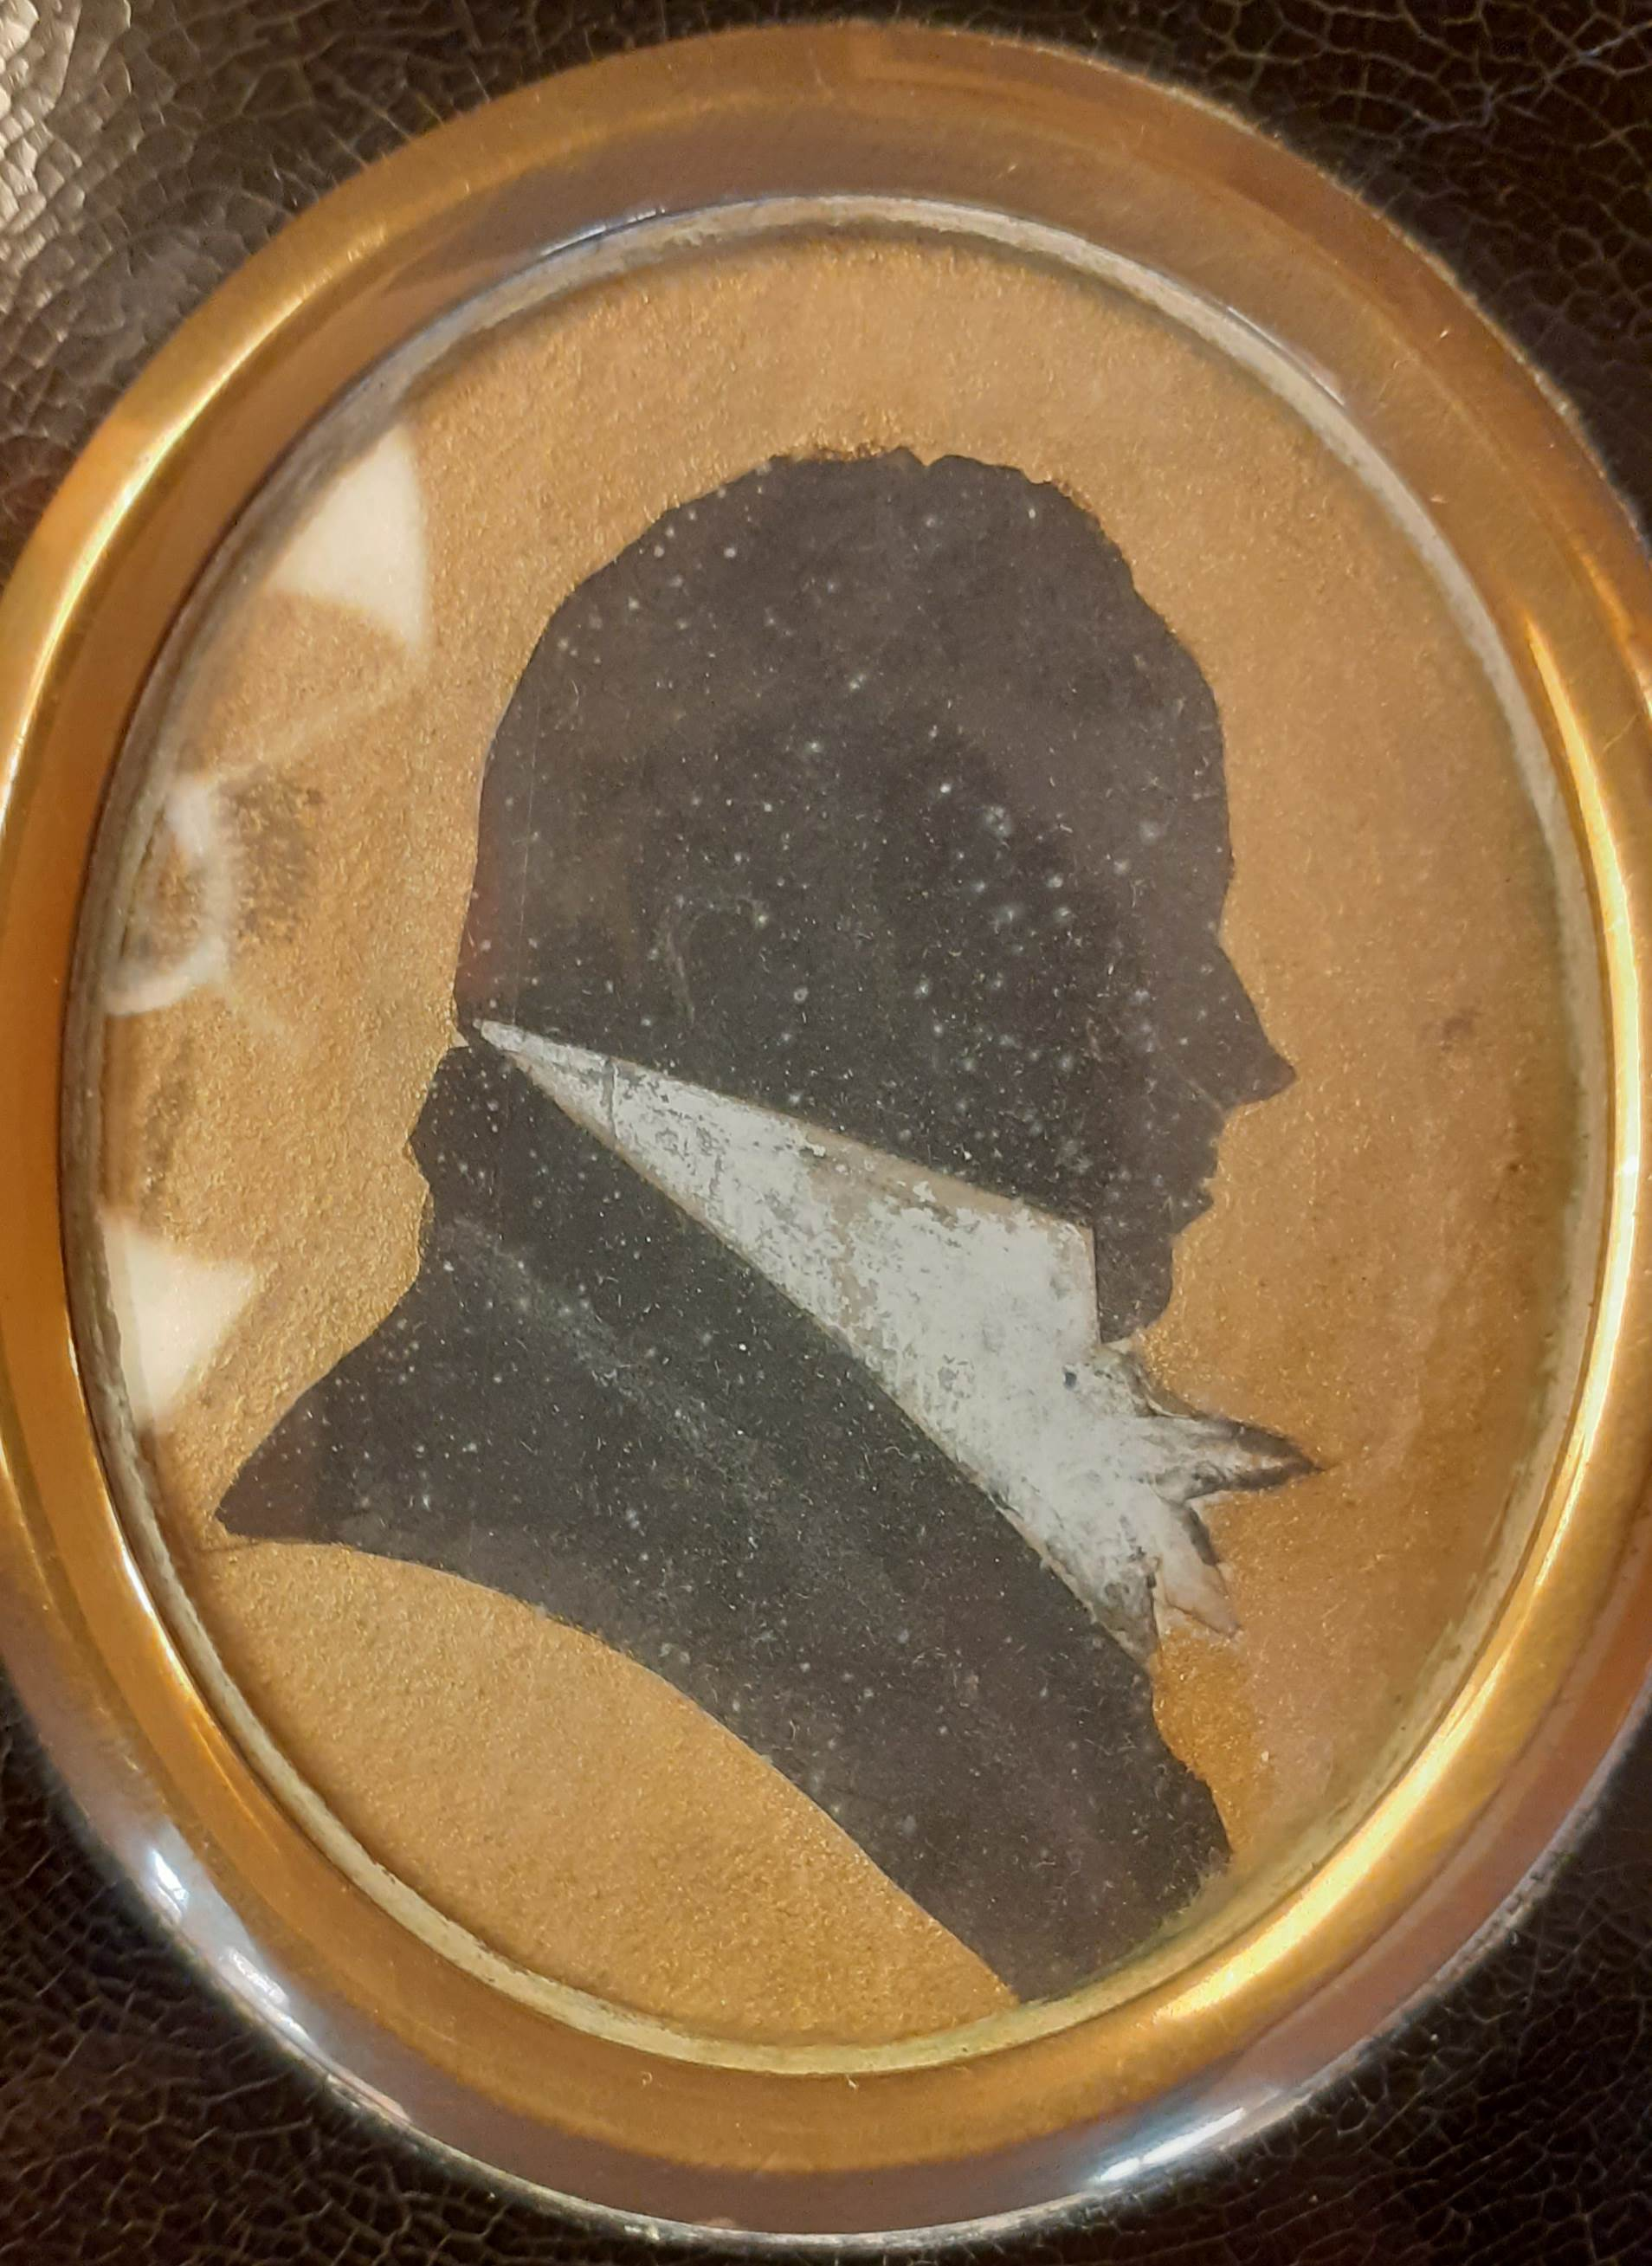

Daniel O’Connor born about 1778
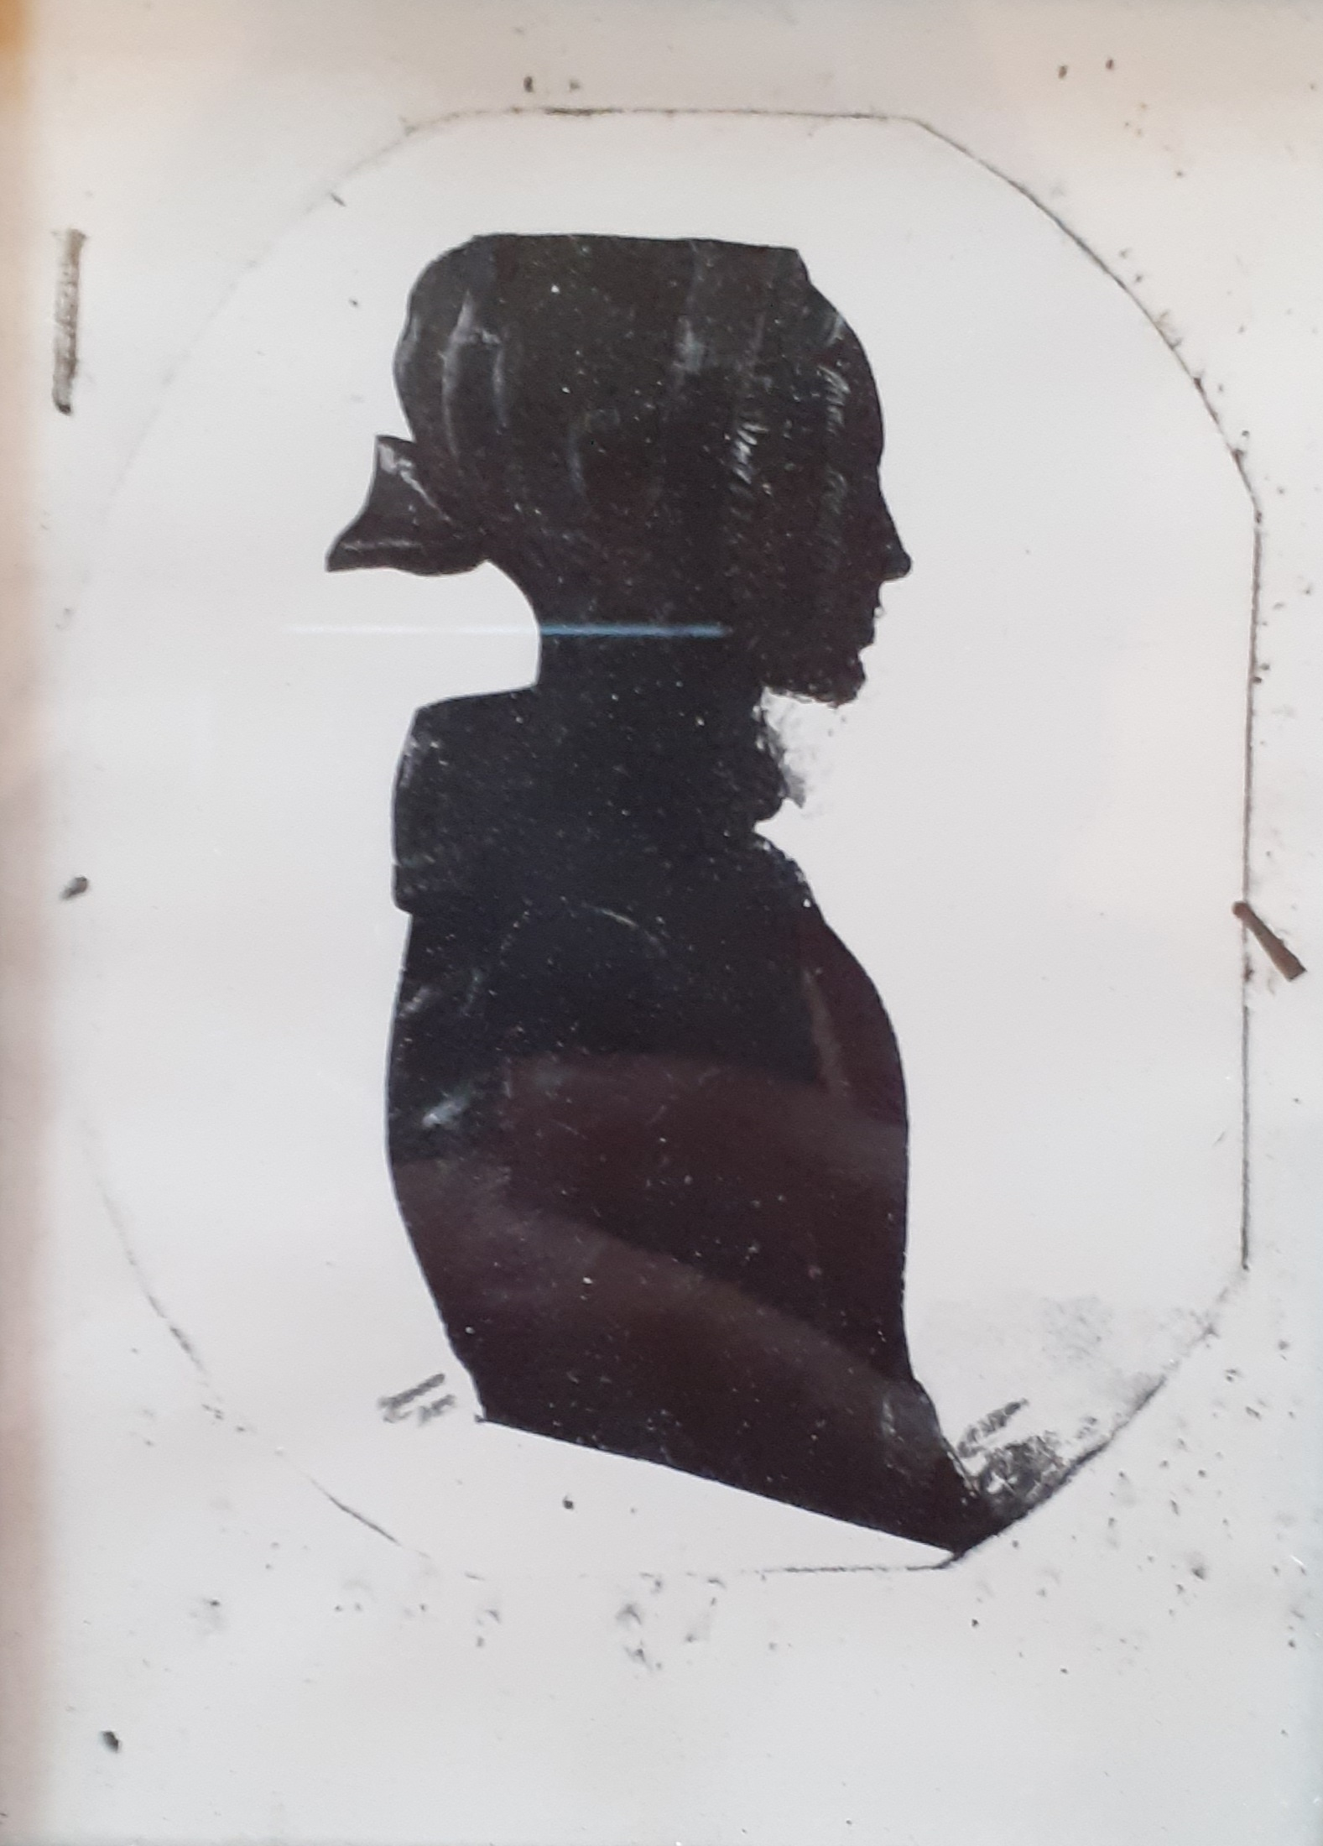

Aunt Benn, Isabella O’Connor daughter of Daniel O’Connor and Elizabeth Walplate, who married Ewer Benn

